**NATIONAL INSTITUTE OF TECHNOLOGY SILCHAR**

**Cachar, Assam**

**B.Tech. IVth Sem**

**Subject Code:** CS215

**Subject Name:** Signals and Data Communication

**Submitted By:**

Name : Subhojit Ghimire

Sch. Id. : 1912160

Branch : CSE – B

1. **Consider an analog signal x(t) = 4cos(2πt) defined for –Ꝏ < t < +Ꝏ. For the following values of the sampling period Ts, generate a discrete-time signal x[n] = x (nTs) = x(t)t = nTs**
2. **Ts = 0.1 sec**
3. **Ts = 0.5 sec**
4. **Ts = 1.0 sec**

* **AIM: To sample an analog signal x(t) = 4cos(2πt) defined for –Ꝏ < t < +Ꝏ for different sample values of Ts and generate a discrete-time signal x[n] = x (nTs) = x(t)t = nTs**

**THEORITICAL BACKGROUND:**

**Analog Signal:** An analog signal is any continuous signal for which the time-varying feature of the signal is a representation of some other time-varying quantity, i.e., analogous to another time-varying signal.

**Discrete-time Signal:** A discrete signal or discrete-time signal is a time series consisting of a sequence of quantities. It is not a function of a continuous argument, however, it may have been obtained by sampling from a continuous-time signal.

**Discrete Function:** It is a function in which the domain and range are each a discrete set of values, rather than an interval in R. If a function is discrete, it does not include all of the values between two given numbers, but rather only specific values in a particular range.

**METHODOLOGY:**1. For a given sampling period Ts, a vector of discrete points is generated.  
2. For the analog signal x(Ts), discrete-time signal is calculated.  
3. The discrete (x, t) pairs are plotted using stem plot.

**CODE:**

clear all

clc

T=3;

Tss= 0.0001;

t=[0:Tss:T];

xa=4*cos(2*pi*t);

xamin=min(xa);

xamax=max(xa);

figure(1)

subplot(221)

plot(t,xa);

grid

title('Continuous-time Signal');

ylabel('x(t)');

xlabel('t sec')

axis([0 T 1.5*xamin 1.5*xamax])

N=length(t);

for k=1:3,

if k==1,Ts= 0.1;

subplot(222)

t1=[0:Ts:T];

n=1:Ts/Tss: N;

xd=zeros(1,N);

xd(n)=4*cos(2*pi*t1);

plot(t,xa);

hold on;

stem(t,xd);

grid;

hold off

axis([0 T 1.5*xamin 1.5*xamax]);

ylabel('x(0.1 n)');

xlabel('t')

elseif k==2, Ts=0.5;

subplot(223)

t2=[0:Ts:T];

n=1:Ts/Tss: N;

xd=zeros(1,N);

xd(n)=4*cos(2*pi*t2);

plot(t,xa);

hold on;

stem(t,xd);

grid;

hold off

axis([0 T 1.5*xamin 1.5*xamax]);

ylabel('x(0.5 n)');

xlabel('t')

else,Ts=1;

subplot(224)

t3=[0:Ts:T];

n=1:Ts/Tss: N;

xd=zeros(1,N);

xd(n)=4*cos(2*pi*t3);

plot(t,xa);

hold on;

stem(t,xd);

grid;

hold off

axis([0 T 1.5*xamin 1.5*xamax]);

ylabel('x(n)');

xlabel('t')

end

end

**INPUT DATA DESCRIPTION:**There are three different sample periods: 0.1 sec, 0.5 sec and 1.0 sec.

**RESULT:**

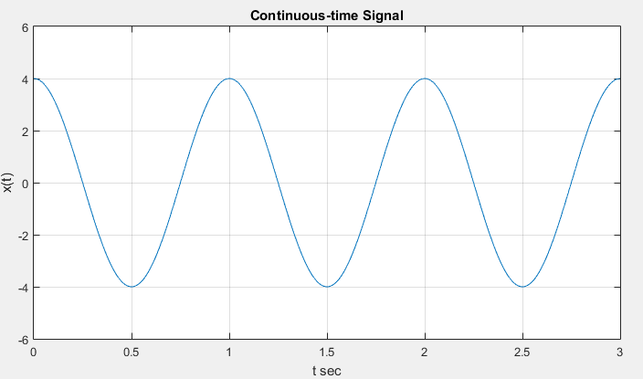

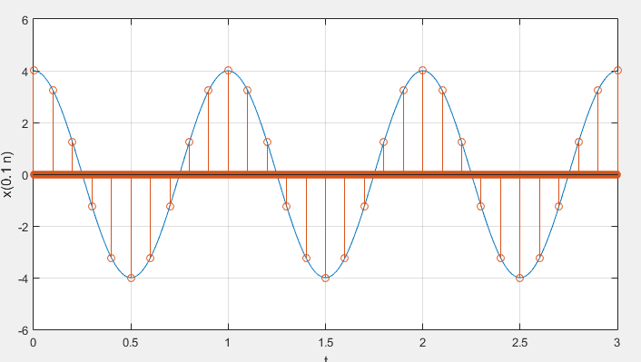

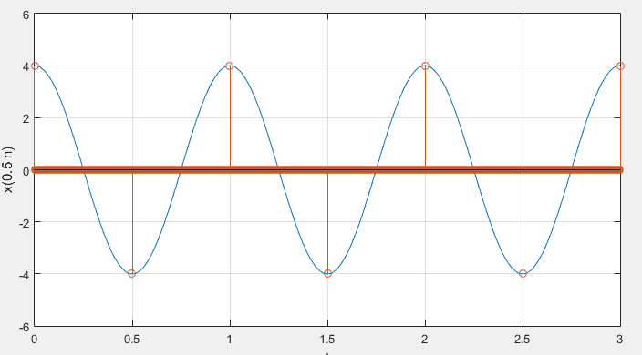

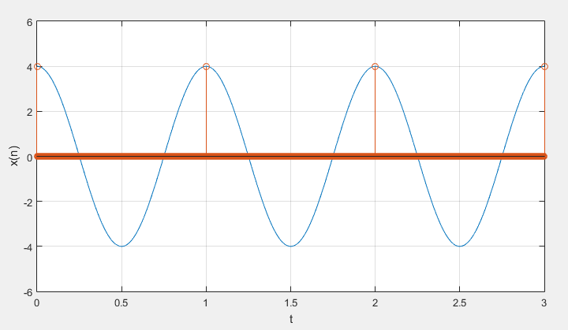

**CONCLUSION/DISCUSSION:**

It can be seen from the above graphs that the information is lost with increasing sampling periods.

1. **In the above experiment, determine for which values of Ts the discrete-time signal has lost information in the analog signal. Plot the analog signal and the discrete-time signals. Superimpose the analog and the discrete-time signals for 0 ≤ t ≤ 3; plot all four figures in one plot.**

* **AIM: TO DETERMINE THE DISCRETE-TIME SIGNAL THAT HAS LOST INFORMATION IN THE ANALOG SIGNAL AND SUPERIMPOSE THE ANALOG AND THE DISCRETE-TIME SIGNALS FOR THE GIVEN SAMPLING PERIODS.**

**THEORITICAL BACKGROUND:**

**Analog Signal:** An analog signal is any continuous signal for which the time-varying feature of the signal is a representation of some other time-varying quantity, i.e., analogous to another time-varying signal.

**Discrete-time Signal:** A discrete signal or discrete-time signal is a time series consisting of a sequence of quantities. It is not a function of a continuous argument, however, it may have been obtained by sampling from a continuous-time signal.

**Sampling of Analog Signal:** It is the process of measuring the instantaneous values of continuous-time signal in a discrete form.

**METHODOLOGY:**1. For each sampling period, three sets of discrete points are obtained.  
2. The corresponding sets of values are calculated.  
3. All sets of (x, t) pairs and the analog signals are plotted.

**CODE:**

clear all

clc

hold on

t = 0:.1:3;

f=1/3;

x=4*cos(t*2*pi*f);

plot(t, x)

hold on

t = 0:1:3;

f=1/3;

x=4*cos(t*2*pi*f);

stem(t, x)

hold off

**INPUT DATA DESCRIPTION:**

There are three different sample periods: 0.1 sec, 0.5 sec and 1.0 sec.

**RESULT:**

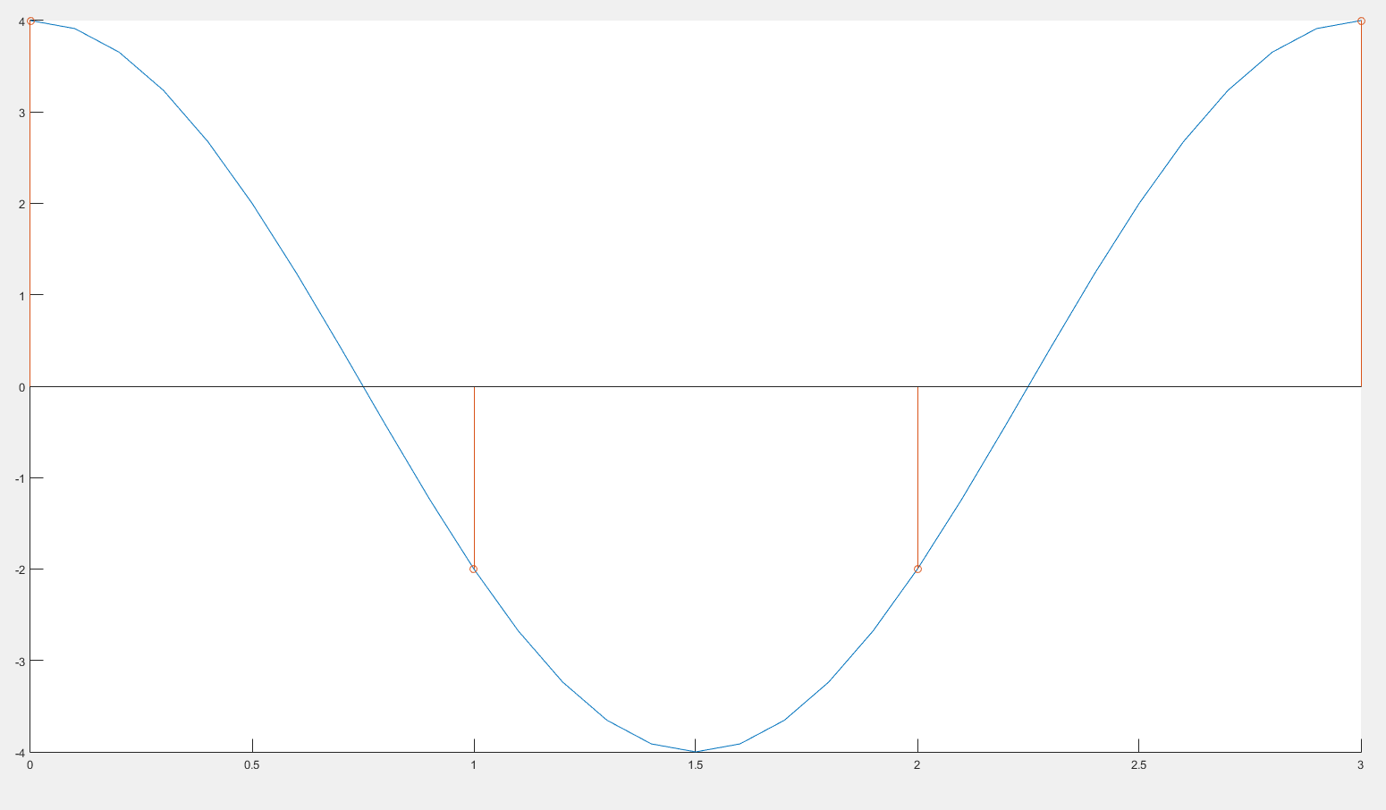

**CONCLUSION/DISCUSSION:**

It can be seen from the above graph that when all the three discrete signals are filtered to produce an analog signal, only the analog signal with sampling period of 0.1 sec resembles the original analog signal, meaning, it retains the information, while other sampling periods produce either a digital clock or a constant signal.

1. **The exponential x(t) = eαt for t ≥ 0 and zero, otherwise is a very common analog signal. Likewise, y[n] = αn for integers n ≥ 0 and zero otherwise is a very common discrete-time signal. Do the following,**
   1. **Let α = –0.5 and plot x(t).**
   2. **Let α = –1.0 and plot x(t).**
   3. **Suppose the signal x(t) is sampled using Ts = 1, what would be x[nTs] and how can it be related to y[n]? Plot and explain.**

* **AIM: TO COMPARE ANALOG SIGNAL EXPONENTIAL x(t) = eαt FOR TWO DIFFERENT VALUES OF α, AND TO DERIVE A RELATION BETWEEN DISCRETE SAMPLING eαt and y[n] = αn.**

**THEORETICAL BACKGROUND:**

**Analog Signal:** An analog signal is any continuous signal for which the time-varying feature of the signal is a representation of some other time-varying quantity, i.e., analogous to another time-varying signal.

**Discrete-time Signal:** A discrete signal or discrete-time signal is a time series consisting of a sequence of quantities. It is not a function of a continuous argument, however, it may have been obtained by sampling from a continuous-time signal.

**Exponential Signal:** It is in the form of x(t) = eαt. The shape of the exponential can be defined by α; i.e., if α = 0, the signal is constant; if α < 0, the signal has the shape of decaying exponential; if α > 0, the signal has the shape of raising exponential.

**METHODOLOGY:**1. The continuous graphs of $e^{-\frac{t}{2}}$ and $e^{-t}$ are plotted simultaneously.  
2. Then, is plotted in another graph, against wich multiple graphs of $α^{n}$ are drawn for comparision.

**CODE:**

clear all

clc

e=2.71;

subplot (222)

t=0:0.01:5;

x=[-2,-1.5,-1,-0.5,0];

y=e.^(-0.5*t);

z=0*x;

axis([-2,5,-1,2]);

plot(t,y,'r',x,z,'r');

subplot (223)

t=0:0.01:5;

x=[-2,-1.5,-1,-0.5,0];

y=e.^(-1.0*t);

z=0*x;

axis([-2,5,-1,2]);

plot(t,y,'r',x,z,'r');

subplot (224)

t=0:0.01:5;

x=0:1:5;

y=e.^(-1.0*t);

a=0.4.^x;

b=0.6.^x;

c=e.^(-1.0*x);

axis([0,5,-0.5,1.5]);

hold on

plot(t,y,'r');

stem(x,a,'b')

stem(x,b,'g')

stem(x,c,'k')

hold off

**INPUT DATA DESCRIPTION:**

There are two values of α: -0.5 and -1.0.

**RESULT:**

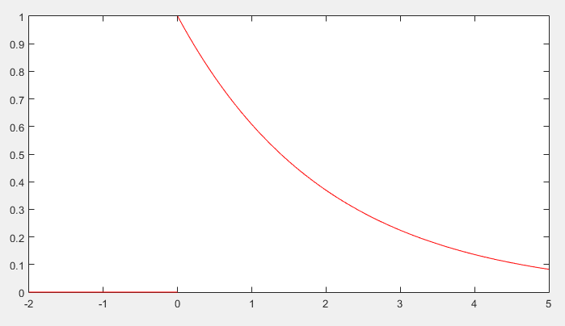

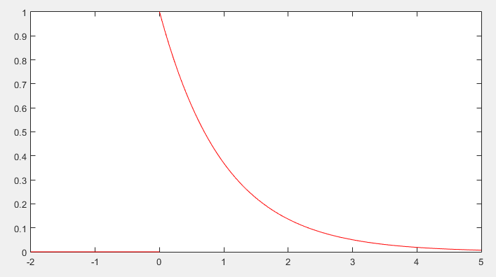

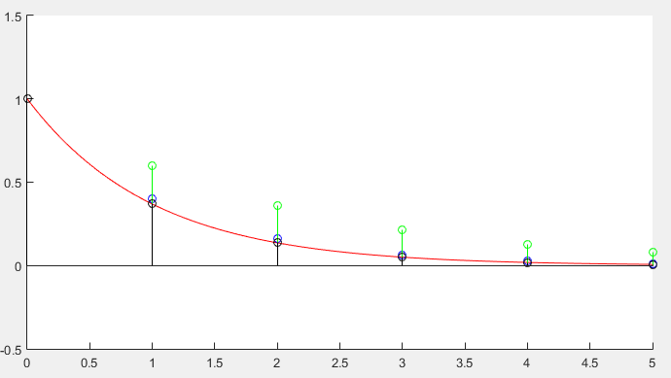

**CONCLUSION/DISCUSSION:**

From the obtained grpahs, we can note that y[n] creates a tight bound on the exponential function $e^{-\frac{n}{2}}$.